Summary:

miniChromosomes are the structures in cells that carry genetic information like DNA, and they have a variety of sizes and shapes.They can control function and use of the cells and pass the function generations to generations.

Minichromosomal technology in agriculture involves artificially creating pieces of genetic material to create special minichromosomal .These minichromosomes are designed to carry specific genes that can benefit plants, such as genes for resistance to pests or diseases, improved growth, or better nutritional content.

Essay:

1:

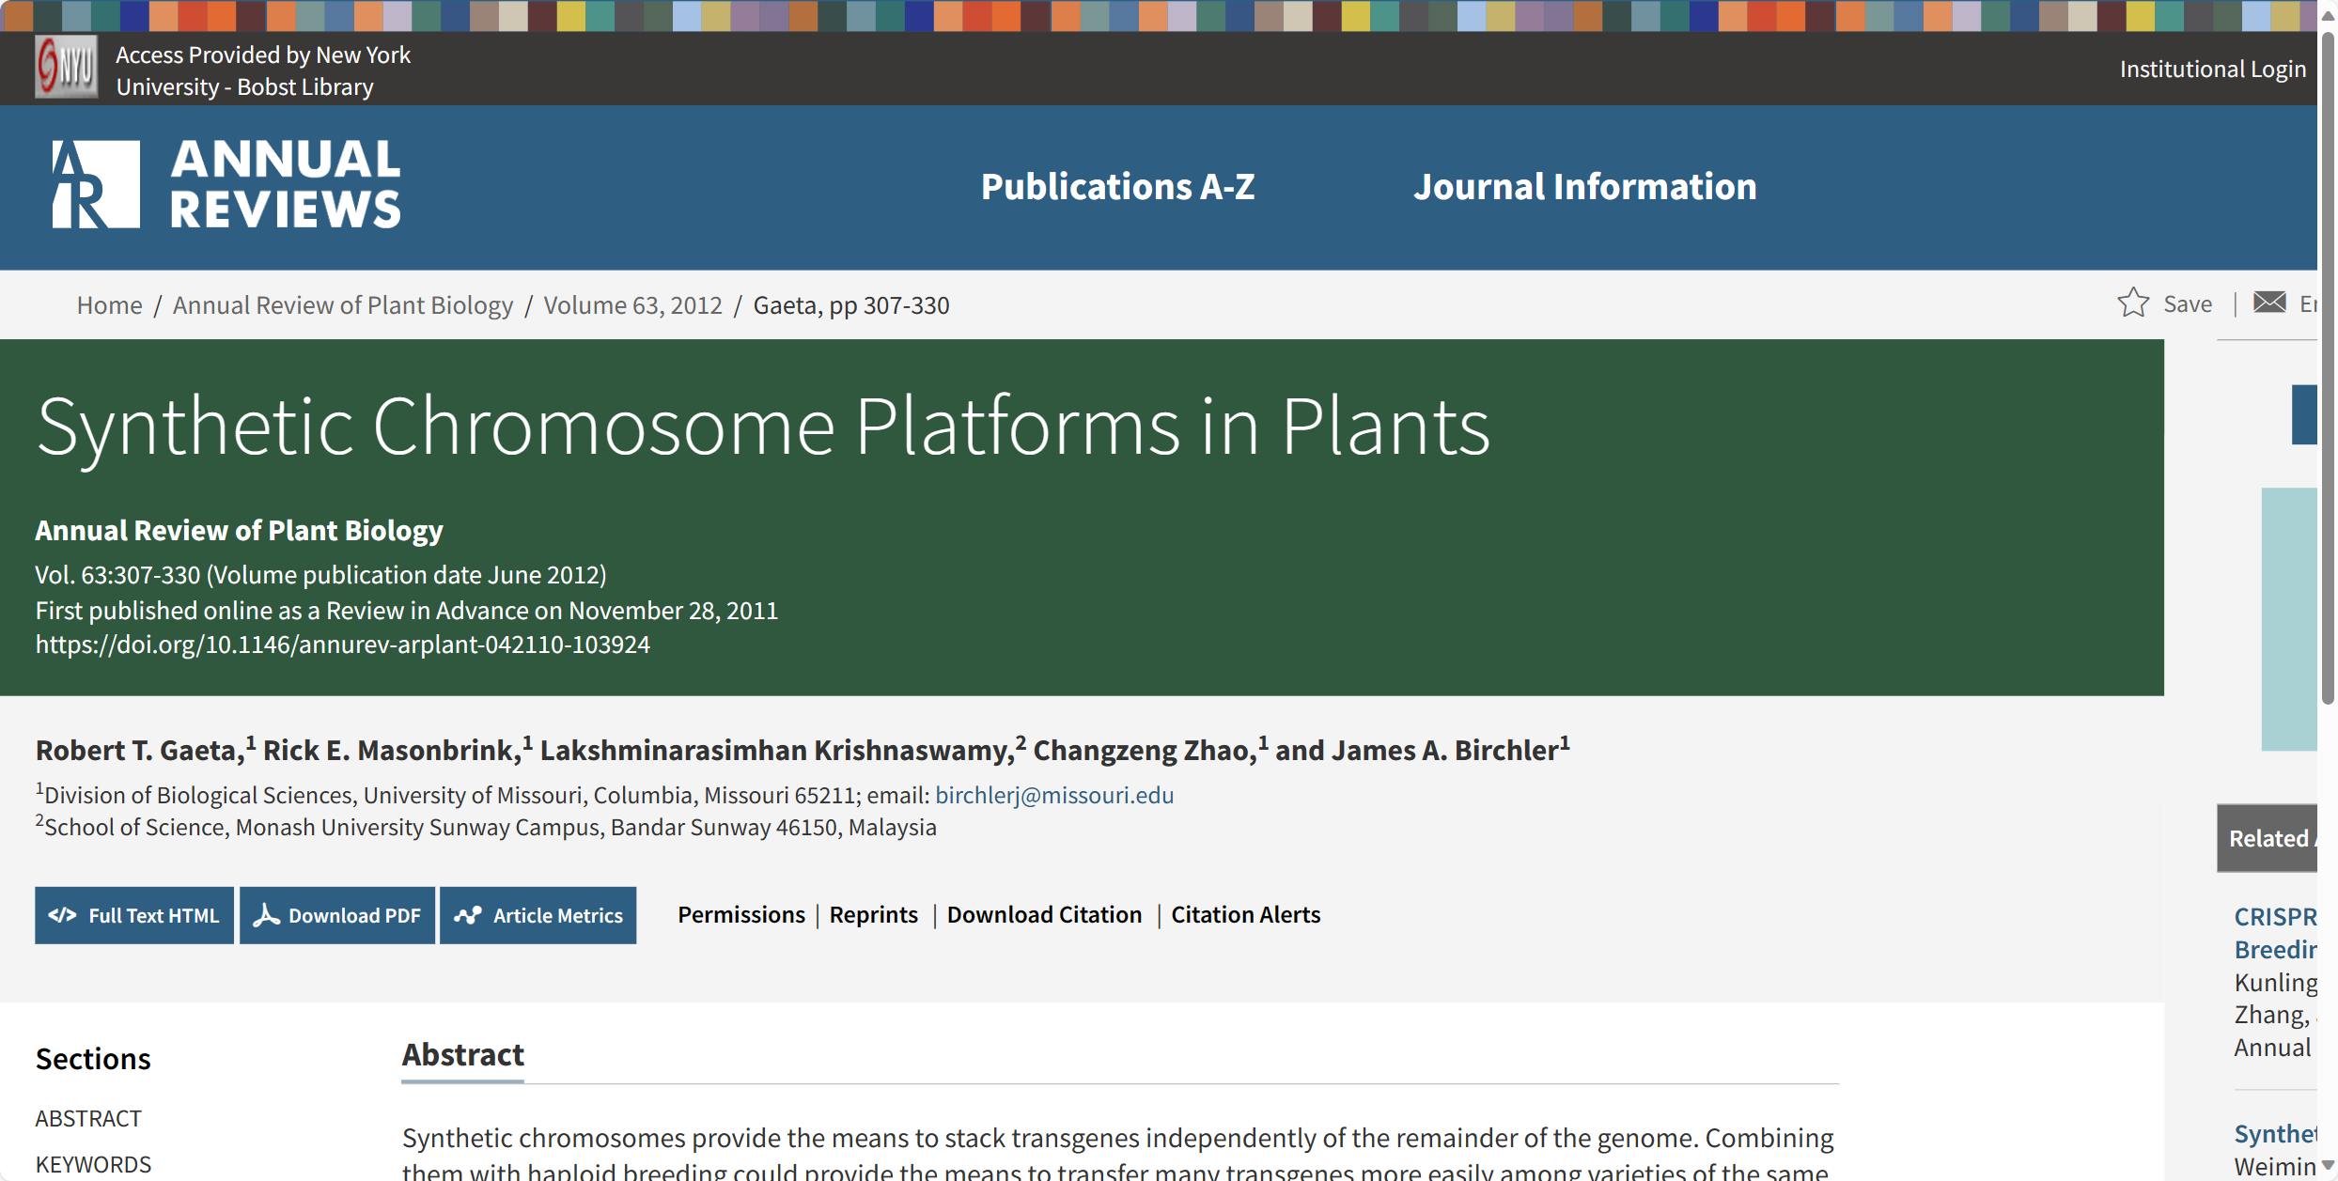

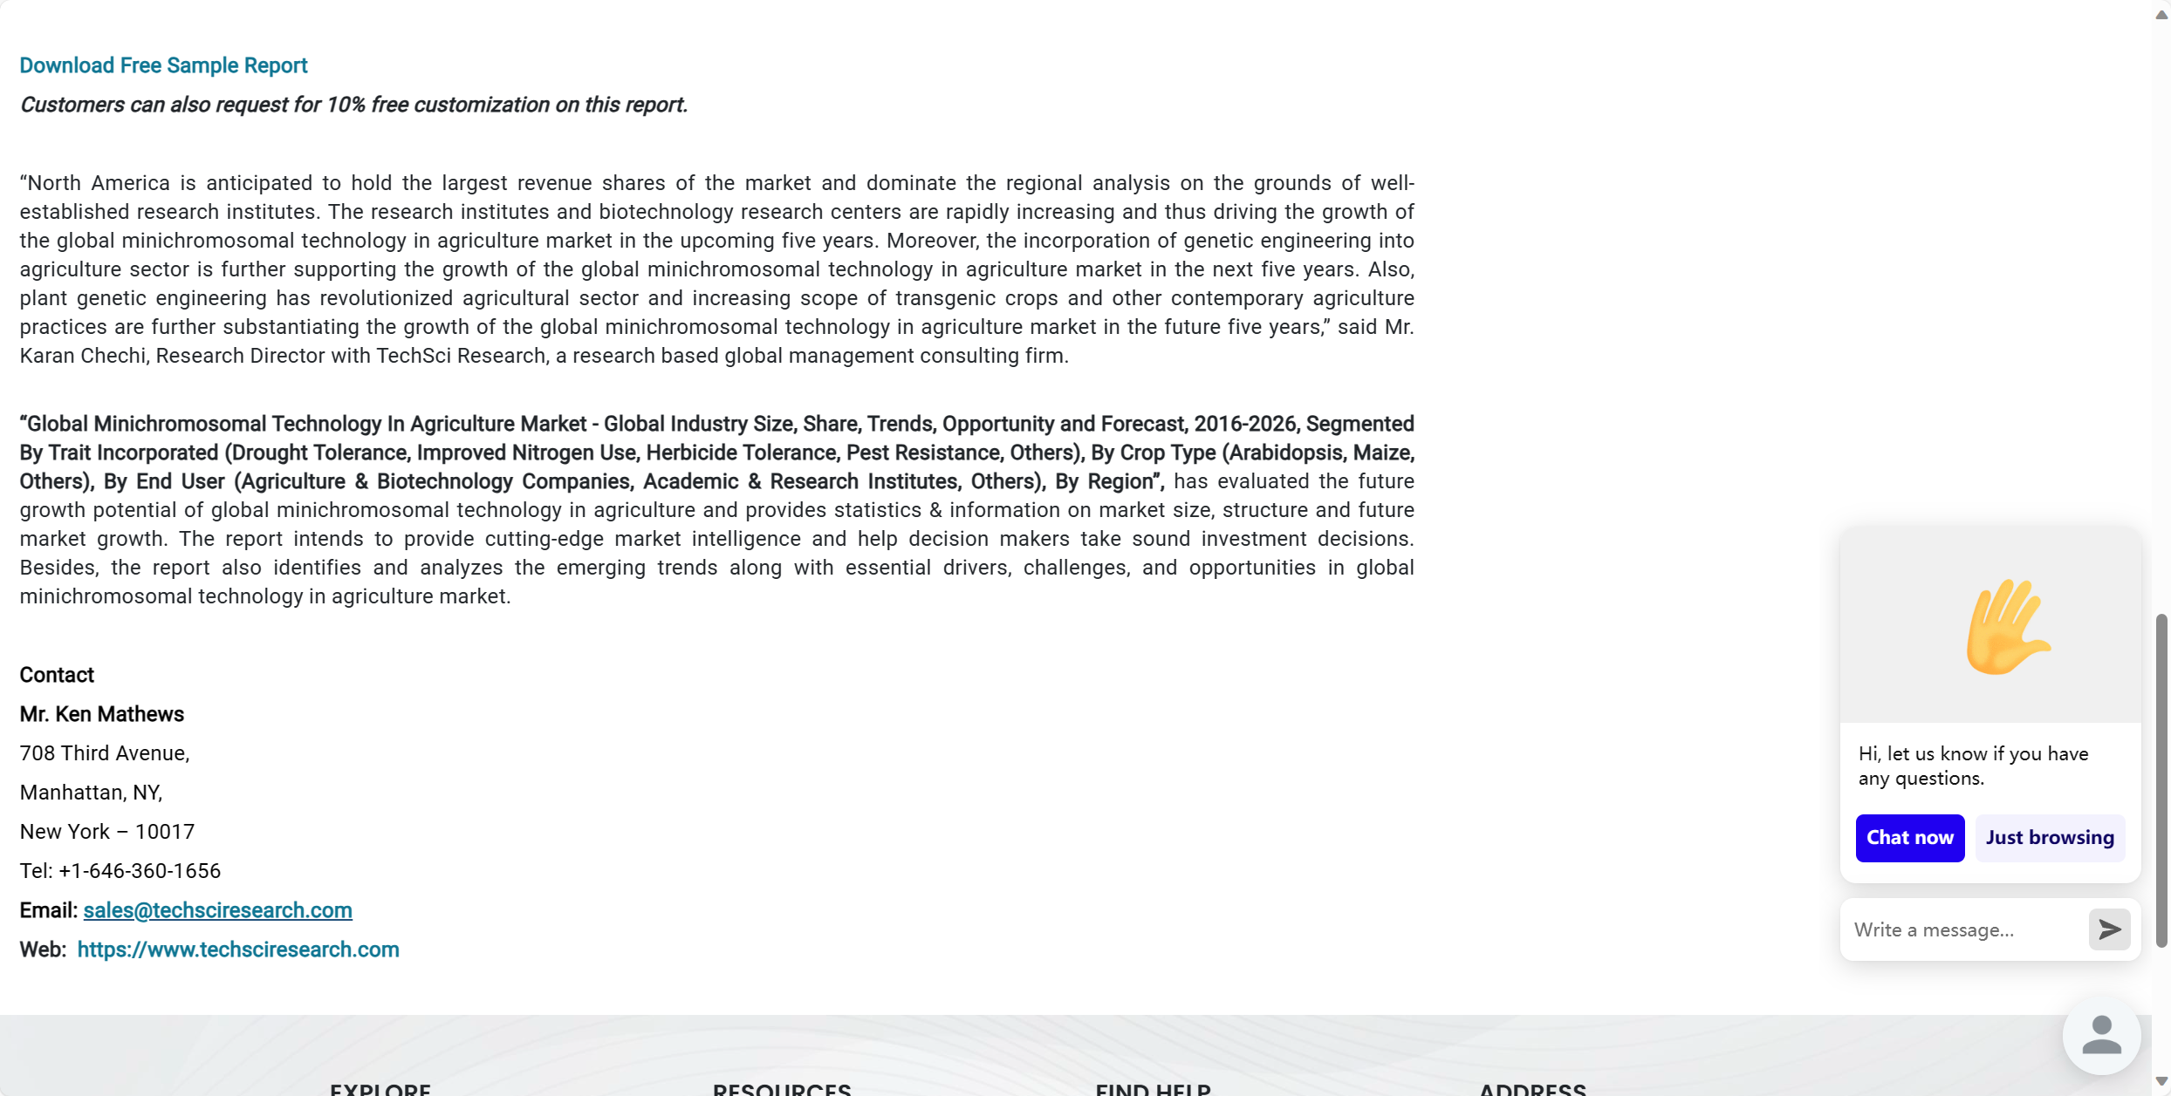

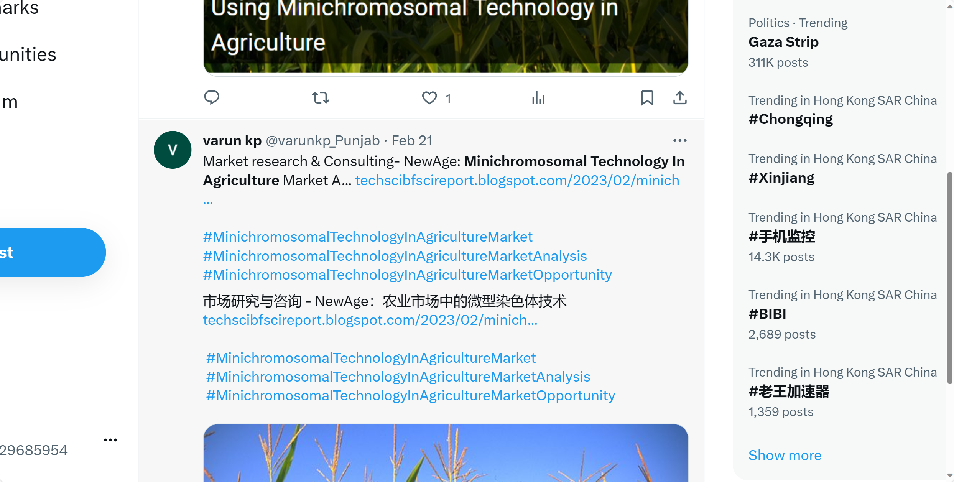

3:

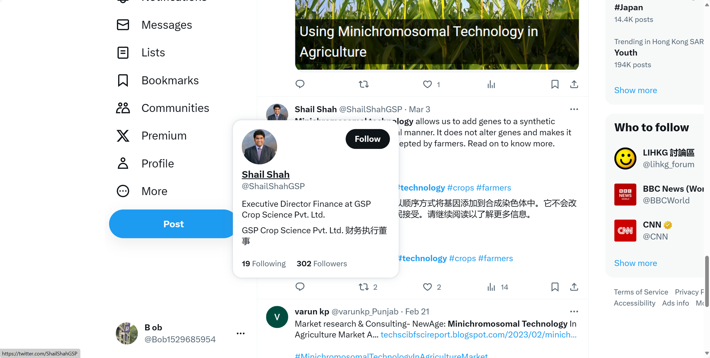

4:



5:

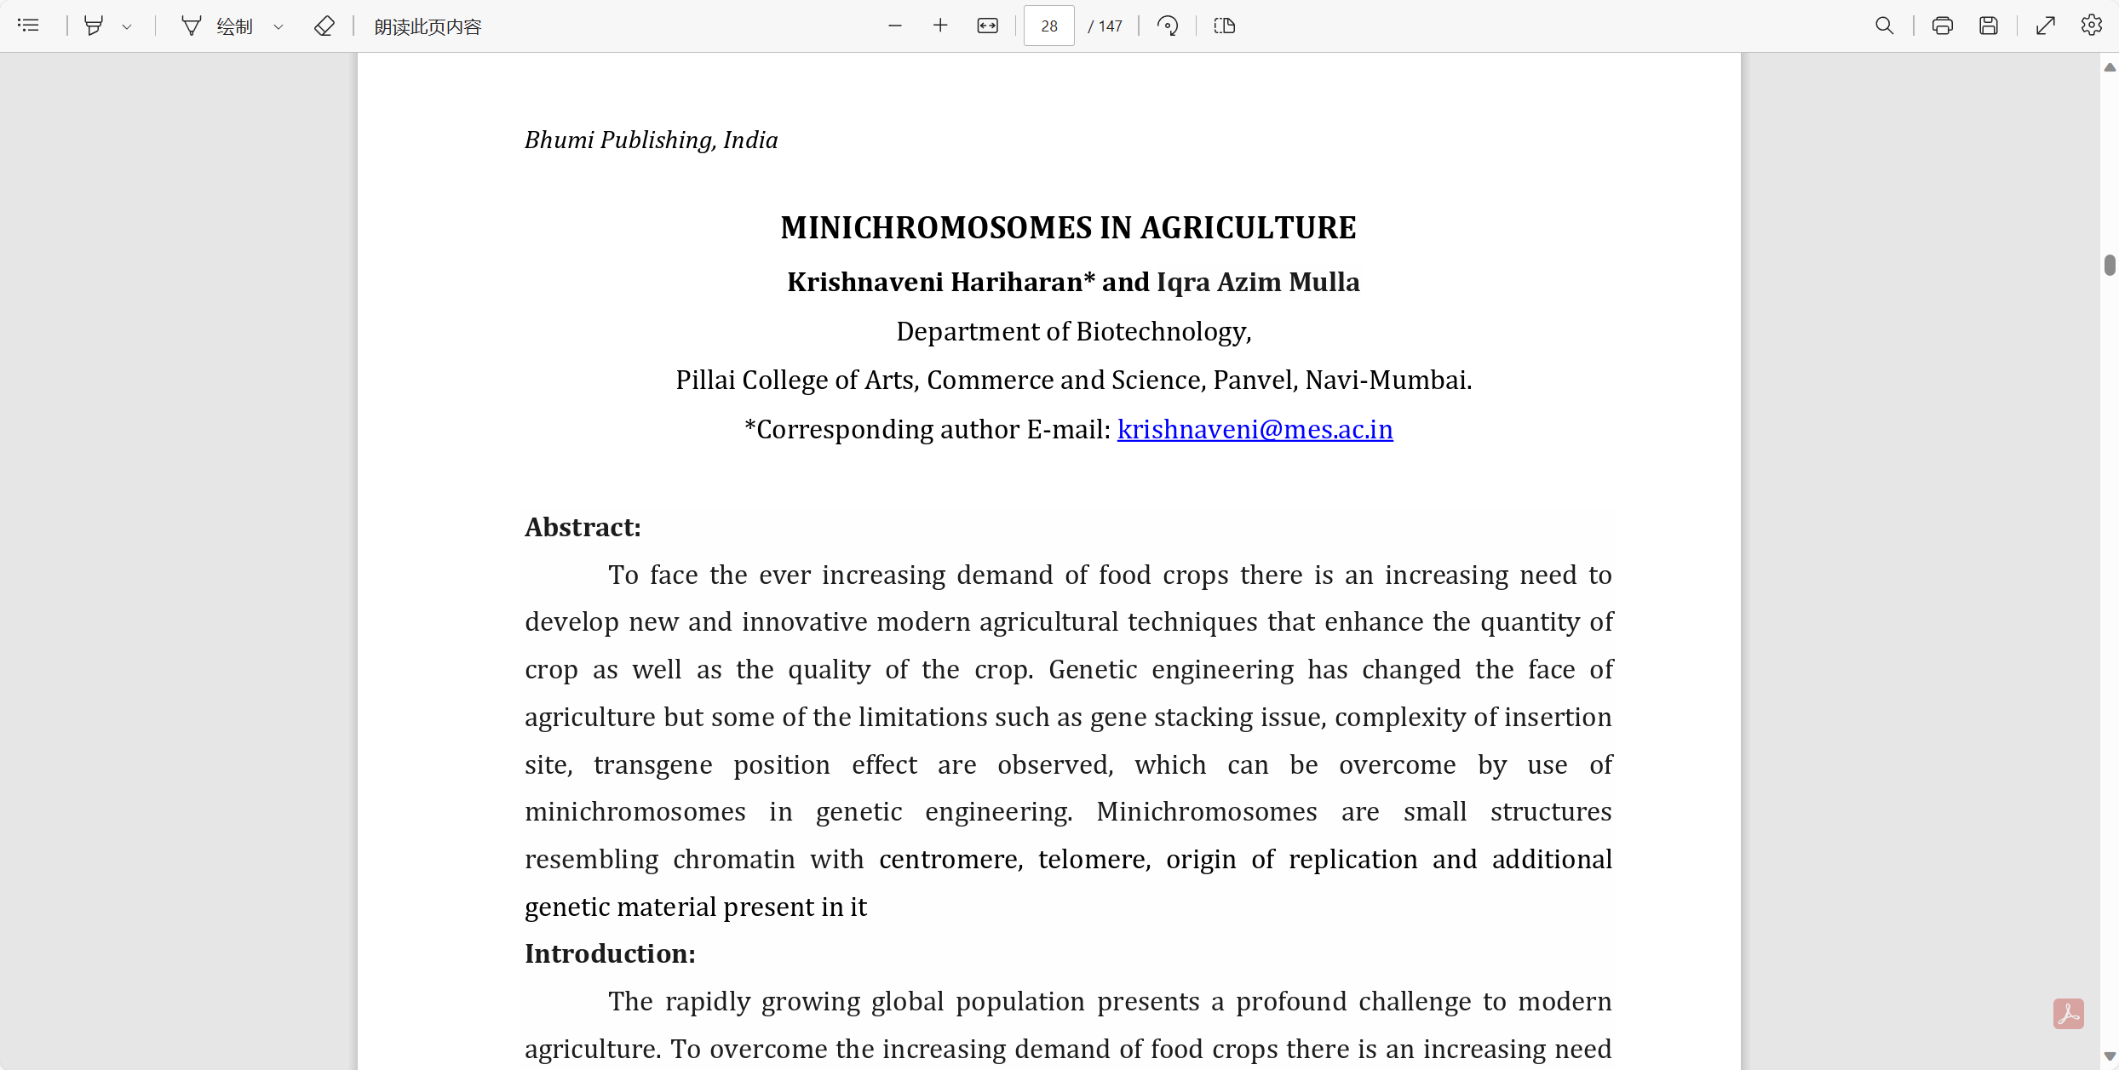

6:

